|  |  |
| --- | --- |
|  | |
| Workaround Invalid STEP Certificate | |
|  |
| Version 1.0 | |
| AUTHOR: Stibo Global Support | |
| CONFIDENTIALITY LEVEL: | |
| Confidential | |
|  | |



**Content**

1 Introduction 3

1.1 Workaround explained 3

# Introduction

This document presents a workaround in case STEP Workbench users having problem launching the application because of the Stibo Systems signed certificate is invalid

## Workaround explained

Go to Java Control Panel:

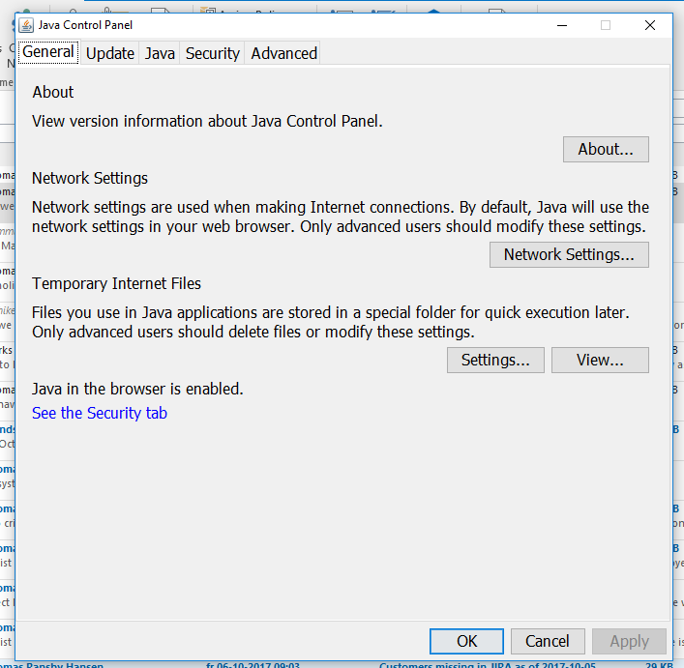

Open Security tab:

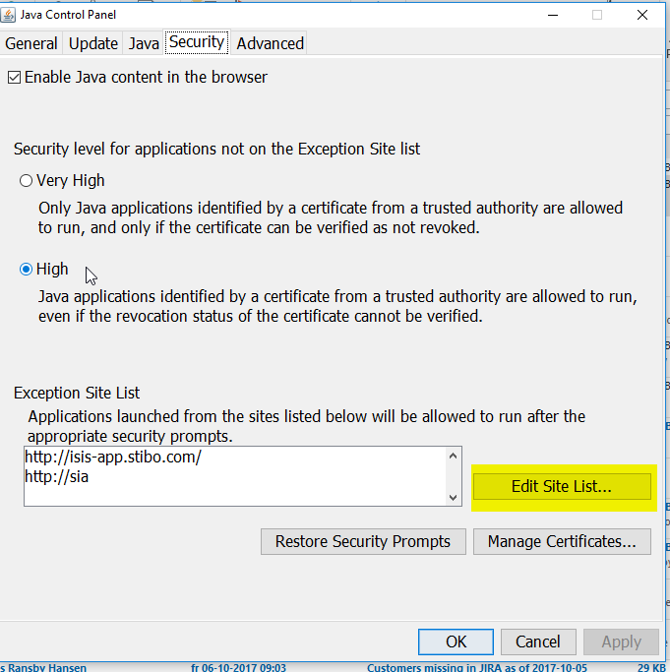

In “Edit Site List” you should on the client add the URL used for launching the Workbench. If you are using a load balancer URL you will also need to add the URL for the different Application Servers to which you are directed.

If you have quite a complex setup with many application servers and possibly load balancers this may be difficult tasks to add to exception list.

The change must be done on each client that will need to launch the STEP Workbench. If possible, it is recommended to deploy this centrally to all clients to minimize effort and ensure consistency in security setting at clients.