Information document for creating “Error”-issues
Version 2.0
AUTHOR: Stibo Systems
CONFIDENTIALITY LEVEL:
Internal

0

Content
1 Objectives 3
2 The new process 3
2.1 What is extracted from your system? 5
3 Business as usual 5

Objectives
The process around creating error issues in JIRA will be slightly changed, because of the new “Send diagnostics” functionality to the STEP software, from version 8.1. This functionality serves to alleviate time spend exchanging information to Stibo Systems Support Team. The overall objective is to immediately extract all necessary system information required to avoid any further time consuming dialog.

This document serves to present the necessary information about these changes, as well as provide instructions for correct creation of these issues.

The new process
Below is a table which seeks to elaborate on the changes made to the process and the current flow. You will find an overview of the steps in the process.
Steps | Examples | Comments
- Recreate problem and note date & time
- Create issue in JIRA | 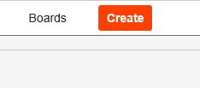 | Please continue to provide all relevant information and steps to reproduce as usual
- Note Issue Key | 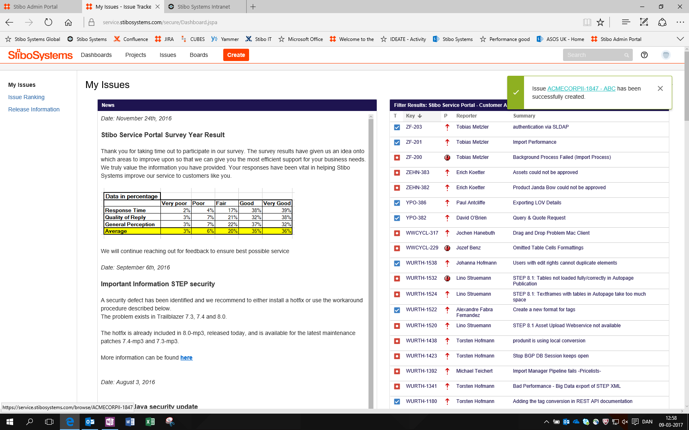
- Go to Admin Portal
- Select the “Send-diagnostics”-tab | 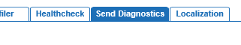
- Check the box “Include Profiling Data” | 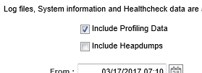 | Heapdump should only be included on request from Stibo Systems
- Submit date & time | 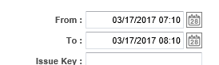
- Submit Issue key | 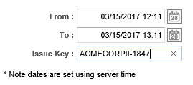 | Please make sure to use capital letters in issue key
- Send Diagnostics | 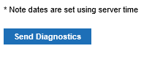
- Return to JIRA
- Assure that link to diagnostic package have been created in the issue | 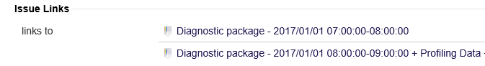  ½ | Please, immediately check the Issue Links area in the relevant issue key for a link to diagnostic package
- IF NO link available, check for correct issue key submitted

What is extracted from your system?
The goal is to extract all necessary information to handle your support request as good and timely as possible. The information collected to Stibo Systems are e.g. logs, sensors and other relevant information.

Business as usual
As stated above, some changes will be made to the way error issues are being created in JIRA. However, some of the current processes and steps to report issues will NOT be changing, which means that we kindly ask you to continue to provide Stibo Systems with all the relevant information available to the given problem. This includes a thorough description of the problem, steps to reproduce and selected lines from logfiles etc. if it’s relevant to the description.

