|  |  |
| --- | --- |
|  | |
| Java Certificate  Workaround | |
|  |
|  | |
| Author: Stibo Systems | |
| Date: October 6th 2015 | |



Java Certificate Work-Around

Content

1.1 Impacts of workaround 3

1.2 By-passing the Security Configuration/Java Certificate issue with Windows Clients 3

1.3 By-passing the Security Configuration/Java Certificate issue with MAC Clients 8

1.4 Java versions prior to Java 7 u51 9

## Impacts of workaround

It is important to note that there is no security risk involved in running the workaround since only the relevant STEP system URL is added to the exception list.

## By-passing the Security Configuration/Java Certificate issue with Windows Clients

1.) From the Control Panel, open up Java.

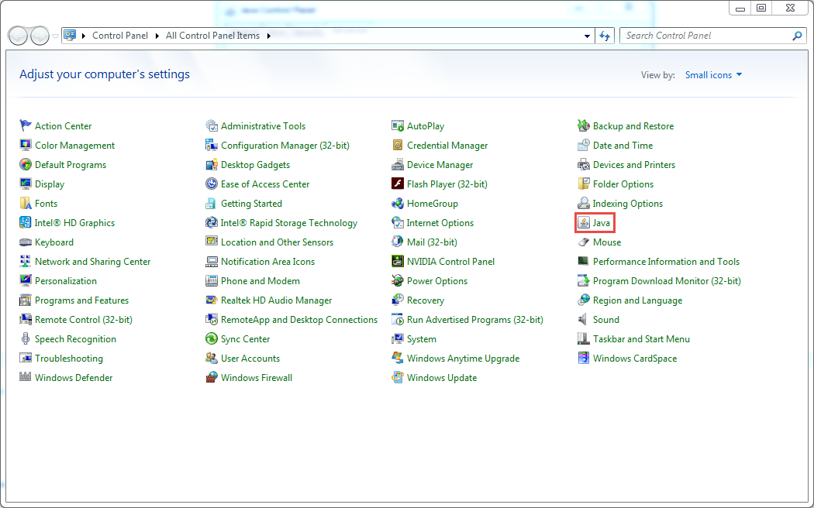

2.) Go to security tab -

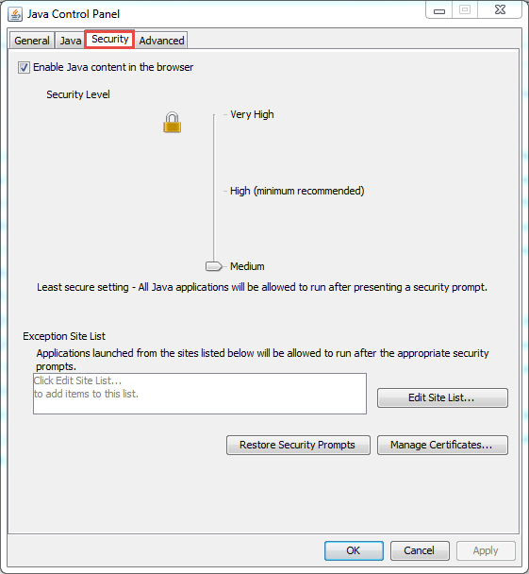

3.) Add site of the server to the exceptions for bypassing this security setting by clicking on "Edit Site List.."

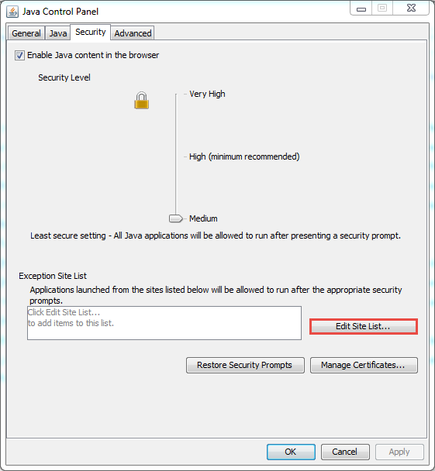

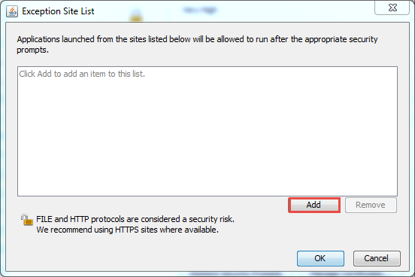

4.) Type the server url you are trying to access. (url on screenshot is just an example.)

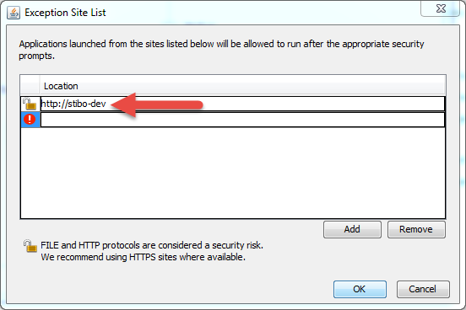

5.) After the above steps, instead of getting the prompt that blocks you from logging in, you will see a warning like the screenshot below:

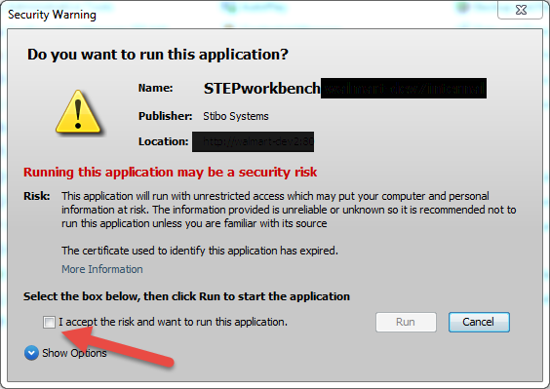

Check "I accept the risk and want to run this application." and continue. It should launch the workbench with no issues.

## By-passing the Security Configuration/Java Certificate issue with MAC Clients

It is similar to the above steps but here are also some screenshots with a MAC client

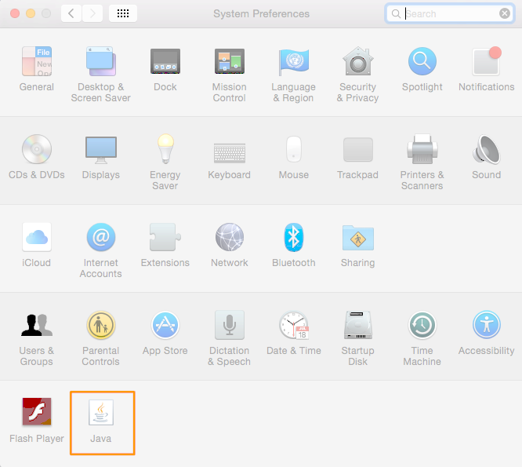

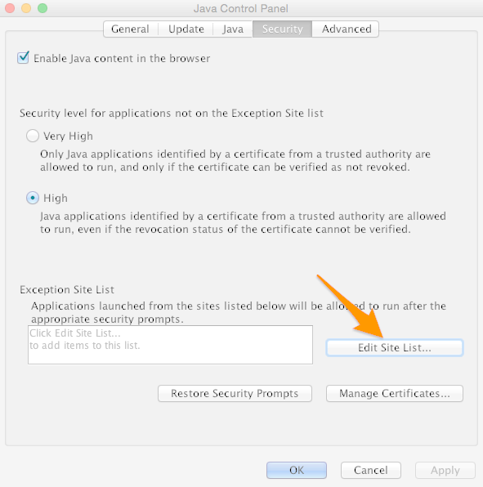

## Java versions prior to Java 7 u51

For older versions there is no exception list handling.

During start-up the error can be ignored by selecting the “Run” button and subsequently suppressed by selecting the checkbox “Always trust content from this publisher”.

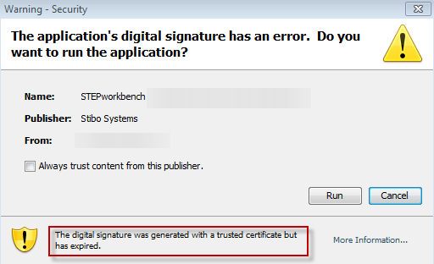

About Stibo Systems

Stibo Systems provides global organisations with a leading multi-domain Master Data Management (MDM) solution. Stibo Systems enables its customers to better manage enterprise intelligence on a global scale, improve sales, and quickly adjust to changes in business requirements. Stibo Systems' STEP technology is a flexible MDM solution that provides a single trusted source of operational information for the entire enterprise. Stibo Systems offers industry-specific solutions, engineered and supported to meet the strategic information needs of global customers including: GE, Sears, Siemens, Target and Thule. Stibo Systems is a subsidiary of the privately held Stibo A/S group, originally founded in 1794 with corporate headquarters in Aarhus, Denmark.

**For more information, please visit www.stibosystems.com**

|  |  |
| --- | --- |
| For more information:  Thomas Ransby  **Email:**trha@stibo.com  Axel Kiers Vej 11  DK-8270 Højbjerg  Danmark | © Stibo Systems A/S all rights reserved. Stibo Systems, STEP, When Success Matters, Global. Integrated. Profits. and other Stibo Systems products and services as well as their respective logos are trademarks or registered trademarks of Stibo Systems A/S. All other company names, products and services used herein are trademarks or registered trademarks of their respective owners. The information published herein is subject to change without notice. This publication is for informational purposes only, without representation or warranty of any kind, and Stibo Systems shall not be liable for errors or omissions with respect to this publication. The only warranties for Stibo Systems products and services are those that are set forth in the express warranty statements accompanying such products and services, if any. Nothing herein should be construed as constituting any additional warranty. |